Bash 02
Create a bash script to check if a directory is available or not.
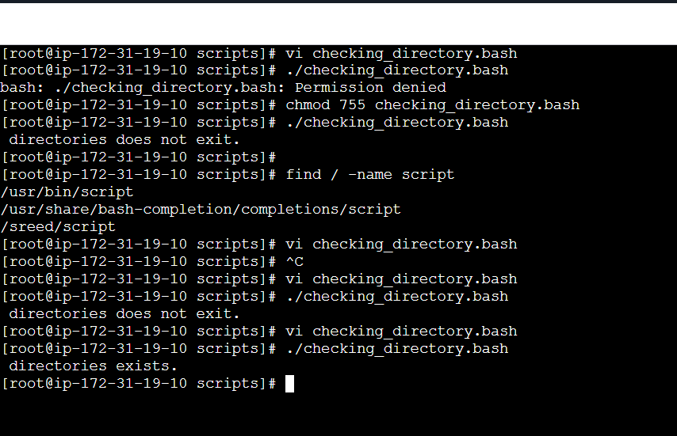
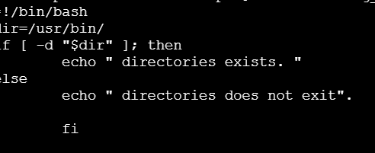
Create a bash script to create multiple files
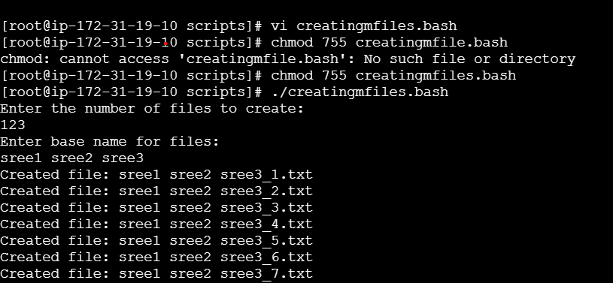

take a backup of a directory

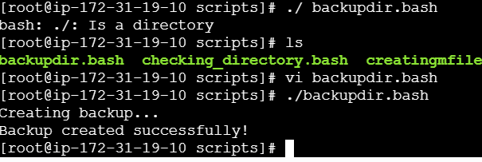
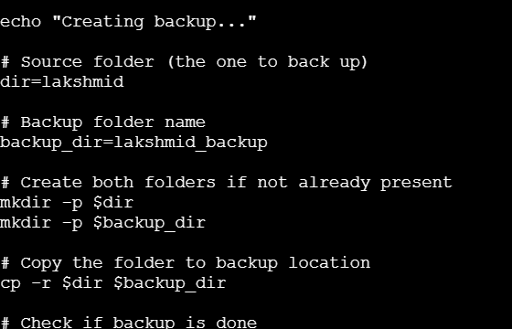
Create a bash script to install Nginx on an EC2 server
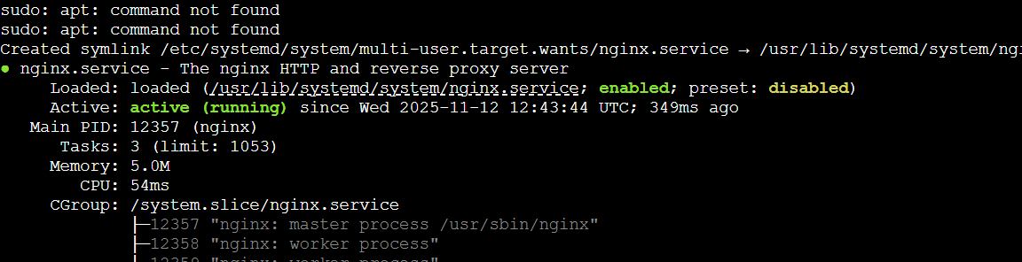

Create a bash script to install Apache Tomcat on an EC2 server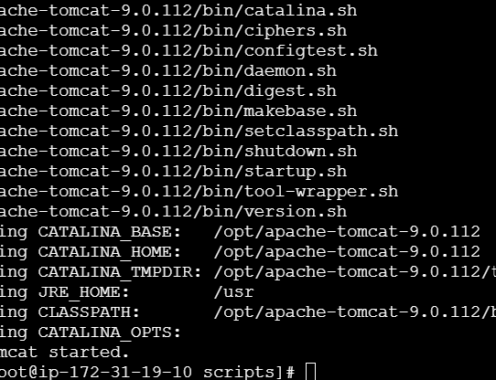
Create a bash script check if the Nginx service is running
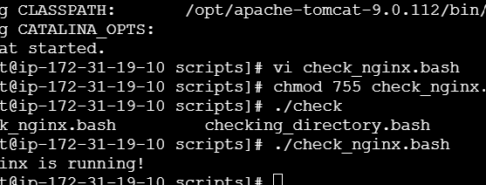
Create a bash script for a calculator
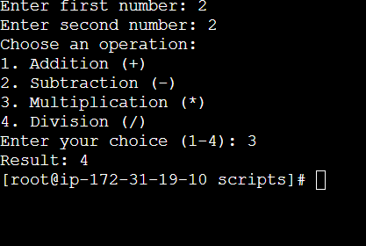
Bash script to monitor memory and if it is more than 80% then send email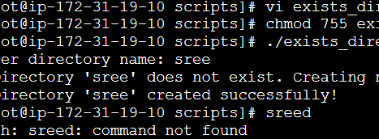
Bash script to monitor disk space and if it is more than 80% then send email
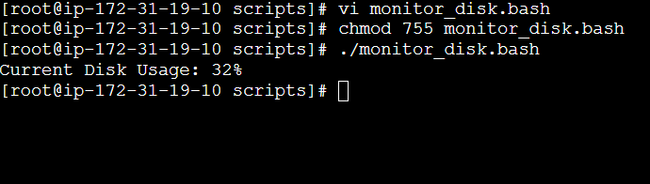
Bash script to monitor memory and if it is more than 80% then send email
